**INDIAN KEFIR COMPANY | YUUVA**

Project 1

Domain 1

Objective 1

Site map 2

Home Page 2

Products Page 3

Products Details Page 3

Cart 3

About Page 3

Account Page 4

Contact Us Page 4

# Project

Probiotic Retail Website

# Domain

There are two domains that will show the website

1. <http://indiankefircompany.com/>
2. Yuvva.in

# Objective

Take order and sell probiotic items online.

# Website Theme

The website will have the dark and light mode option.

Theme color palette options are:

* Baby Blue #8AAAE5, White #FFFFF
  + 
* Pastel Orange #FFA351FF, Peach #FFBE7BFF, Custard #EED971FF
  + 

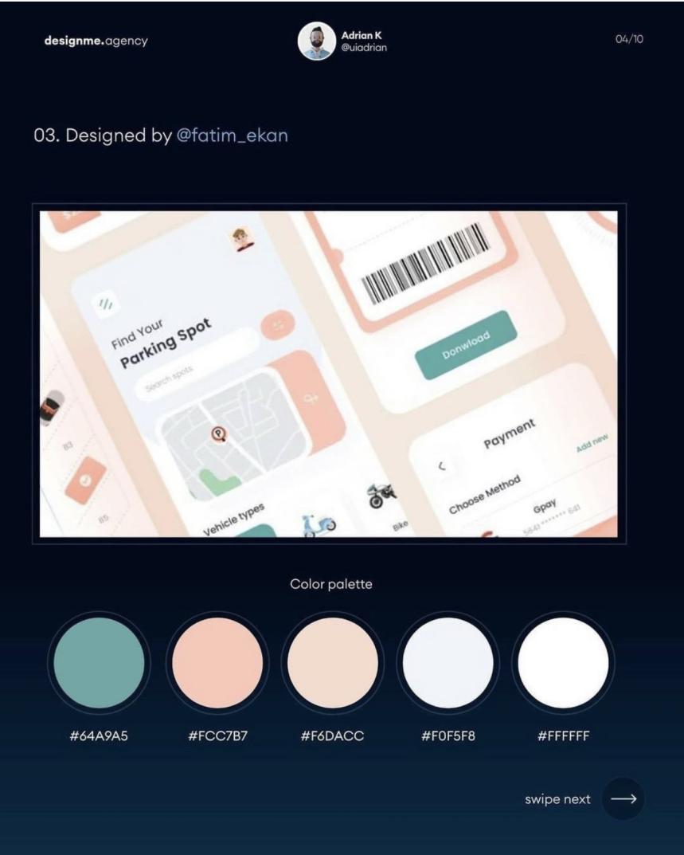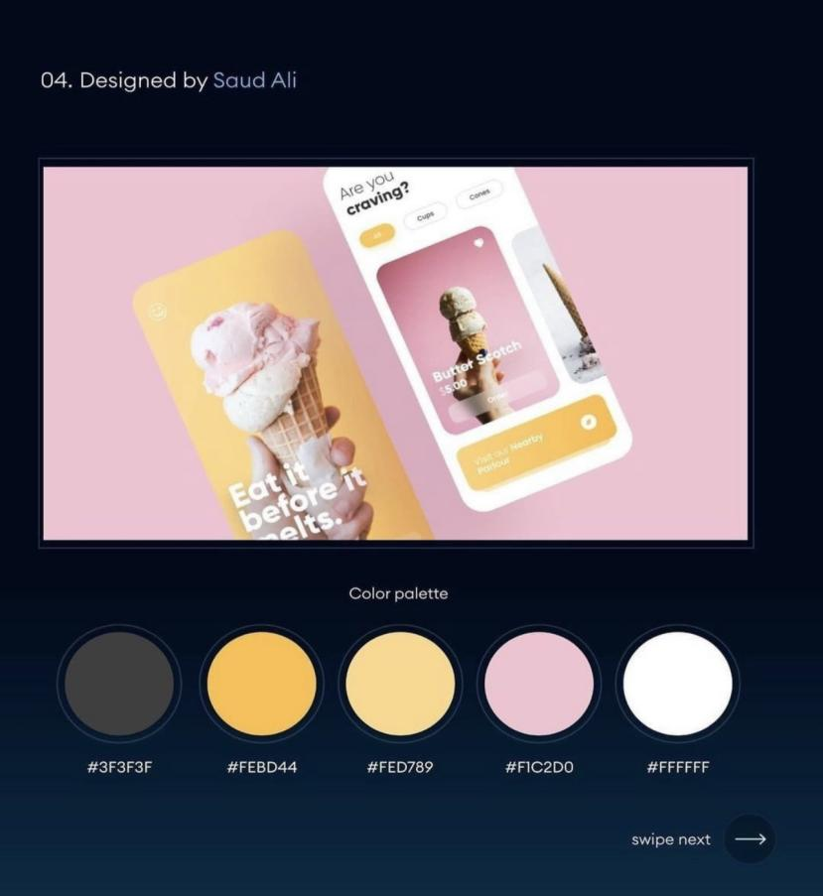

# Site map

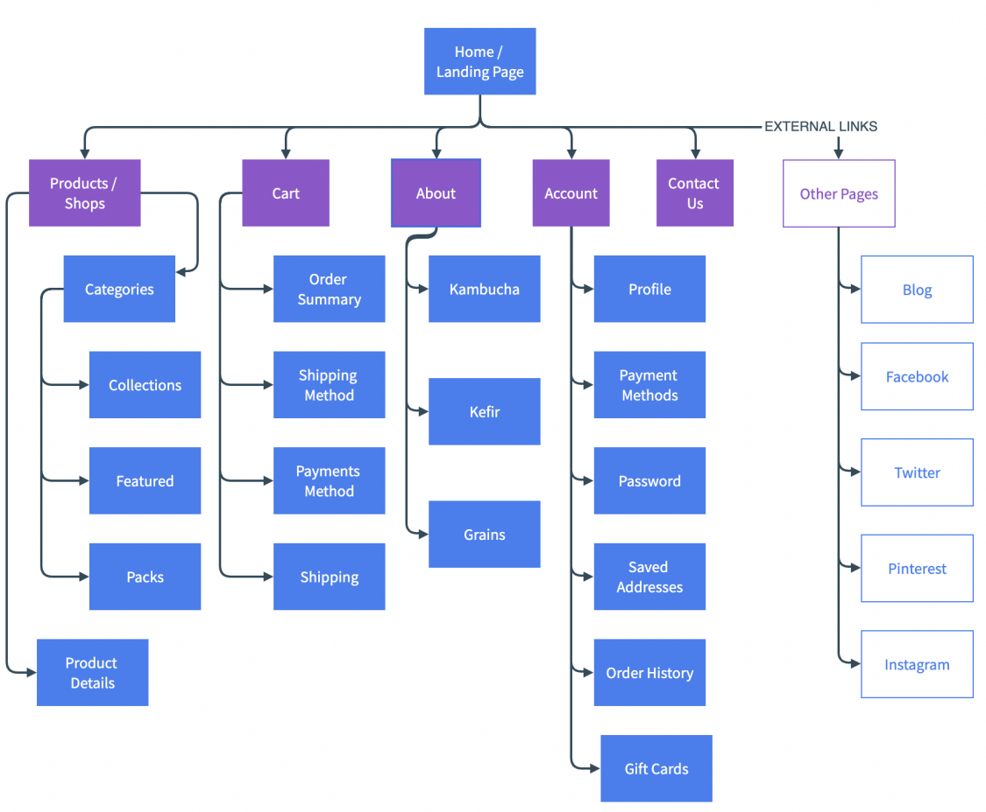

# Home Page

1. Navigation on Top ( For all the pages )
   1. hidden when scrolling down, else visible
   2. Or background transparent, display white color when hover

* Hamburger Menu ( opens from left side )
* Logo ( in middle )
* Products ( link to all products page)
* Search bar ( only icon )
* Location selection
* Cart (only icon)

2. Container:

Image slider with options:

1. Buy specific packs/items
2. Shop Now
3. Container: 6 items + show all product option - minimal design, shows add to card on hover
   1. Row 1 : Kefir items
   2. Row 2 : Kambucha items - minimal design, shows add to card on hover
   3. Row 3: All other items - minimal design
4. Container: How we make (product) - process design
5. Footer: contact us, social icons, about us in brief, location, other pages links

**Fixed items**: (for all the pages)

up arrow for user to scroll smoothly to the top - not visible on first container

Top fixed small height row for shipping message or any other message

# Products Page

1. Filter ( category, price range)
2. Product Cards -> shows products details page on Click
3. Add to cart option

# Products Details Page

1. Product image on left
2. Products details on right
3. Add to cart option
4. Save for later option
5. Bottom container with product suggestions

# Cart

1. Products list on left with total price including shipping if any
2. Payment method on the right side in collapsible containers
3. Option to continue shopping

# About Page

1. Products details container, how they been made and packed
   1. Kefir
   2. Kambucha
   3. Grains

# Account Page

1. Shopping history
2. Registration details
3. Updated details option

# Contact Us Page

1. Form to contact
2. Phone/whatsapp numbers